**EXPERIMENT 6**

**DML COMMANDS (COLLEGE SCHEMA)**

**Aim:**

• 1)Insert 5 instances into the tables created in experiment 5.

• 2)Display the tables.

• 3)Add attribute course to student table then insert values.

• 4)Use update to set course for students.

• 5)Delete an attribute.

**Code:**

1)ALTER TABLE student ADD(gender varchar(10));

2)Insert into student values(1,'Ram','dbms',80,'Hyderabad','M','B'),(2,'John','dbms',70,'Hyderabad','M','C'), (3,'Robert','dbms',42,'Hyderabad','M','F'), (4,'Diya','dbms',55,'Hyderabad','F','D'), (5,'Ella','dbms',90,'Hyderabad','F','A');

select * from student;

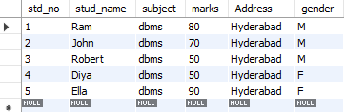

insert into faculty values(1,'Ram','dbms',50,'cse'),(2,'John','dbms',50,'cse'),(3,'Robert','dbms',50,'eee'),(4,'Diya','dbms',50,'cse'),(5,'Ella','dbms',50,'it');

select * from faculty;

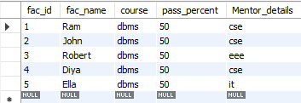

insert into department values(1,'CSE','A',66,50,50),(2,'CSE','B',60,50,40),(3,'CSE','C',60,50,50),(4,'IT','A',60,50,50),(5,'IT','B',60,50,39);

select * from department;

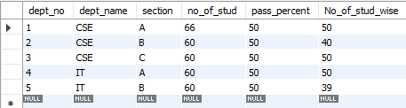

insert into activity values(1,'debate',10,'3','Divya'),(2,'painting',8,'8','Gnyana'),(3,'singing',6,'12','John'),(4,'dancing',12,'5','Raymond'),(5,'coding',7,'18','Sita');

select * from activity;

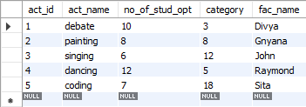

3)ALTER TABLE student ADD(course varchar(40));

4)UPDATE student SET course = "python" WHERE stud_no = 1;

UPDATE student SET course = "c" WHERE stud_no <6 and stud_no>1;

select * from student;

select s.stud_no,f.fac_id from student s,faculty f where s.course=f.course;

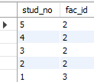

5)delete from student where marks<50;

select * from student;

